**Comparing the Gospels: Week 1 Handout**

Mark - Lion

Matthew - Angel

John - Eagle

Luke - Ox

Ezekiel 1:10 – “As for the appearance of their faces: the four had the face of a human being, the face of a lion on the right side, the face of an ox on the left side, and the face of an eagle”.

Revelation 4:7 – “The first living creature like a lion, the second living creature like an ox, the third living creature with a face like a human, and the fourth living creature like a flying eagle”.

A brief introduction to the “Synoptic Problem”:

|  |  |  |
| --- | --- | --- |
| **Matthew 9:9** | **Mark 2:14** | **Luke 5:27** |
| And having passed on  from there, Jesus saw  a man  seated in the tax office,  named **Matthew**,  and he said to him,  “Follow me”. And having  arisen, he followed him | And having passed on  he saw  **Levi, son of Alphaeus**  seated in the tax office,  and he said to him,  “Follow me”. And having  arisen, he followed him. | And  he saw  a tax collector named **Levi**  seated in the tax office,  and he said to him,  “Follow me”. And **having**  **left everything** and having  arisen, he followed him. |

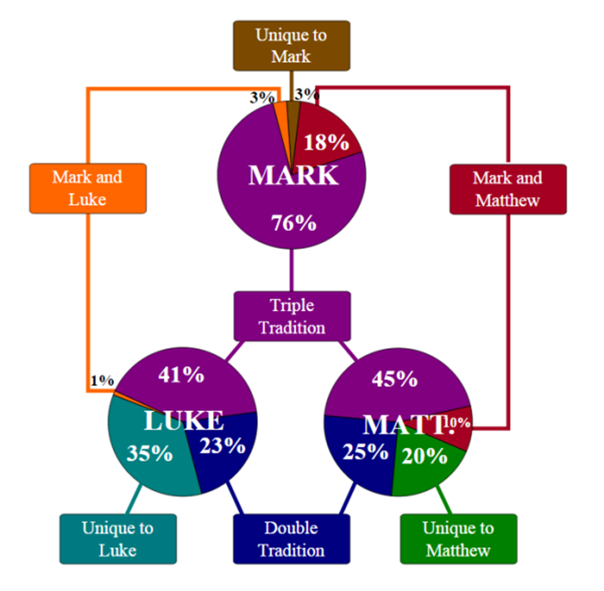

|  |  |  |  |
| --- | --- | --- | --- |
| **Matthew** | **Mark** | **Luke** | **Event** |
| 8:1-4  9:1-8  9:9-13  9:14-17  12:1-8  12:9-14  10:1-4  12:46-50  13:1-23  8:23-27  8:28-34  9:18-26  14:13-21  16:13-20  17:1-8  17:14-20  19:13-15  19:16-30  20:29-34  21-28 | 1:40-45  2:1-12  2:13-17  2:18-22  2:23-28  3:1-6  3:13-19  3:31-35  4:1-20  4:35-41  5:1-20  5:21-43  6:30-44  8:27-30  9:2-8  9:14-29  10:13-16  10:17-31  10:46-52  11-16 | 5:12-16  5:17-26  5:27-32  5:33-39  6:1-5  6:6-11  6:12-16  8:19-21  8:4-15  8:22-25  8:26-39  8:40-56  9:10-17  9:18-21  9:28-36  9:37-43  18:15-17  18:18-30  18:35-43  20 - 24 | Leper  Paralytic  Call of Levi/Matthew  Fasting, New Wine, Patches  Plucking Grain on the Sabbath  Man with Withered Hand  Choosing of the Twelve  Jesus’ Mother and Brothers  Parable of the Sower  Calming of the Storm  Gerasene Demoniac  Jairus’ Daughter and Woman  Feeding of Five Thousand  Peter’s Confession  Transfiguration  Epileptic Boy  Little Children  Rich Young Ruler  Blind Bartimaeus  Passion Narrative |

**Proposed Explanations for Synoptic Relationships:**

(for reference, the “Q” source – from the German word *quelle* – is a hypothesized collection of sayings of Jesus that both Matthew and Luke used as a common source, but that Mark and John seem unaware of)

**The “Two Source” Hypothesis The “Augustinian” Hypothesis**

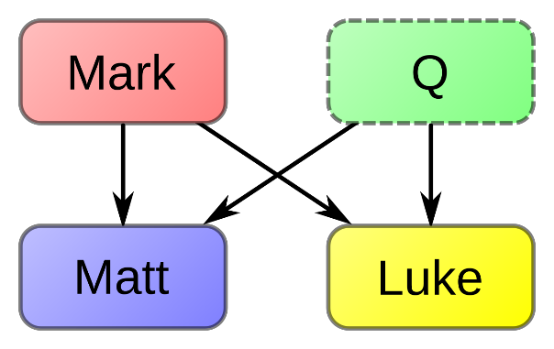 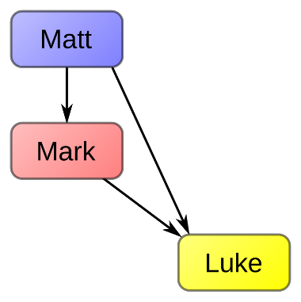

**The “Aramaic Proto Gospel” Hypothesis The “Farrer” Hypothesis**

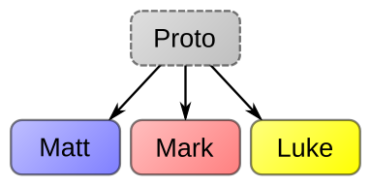 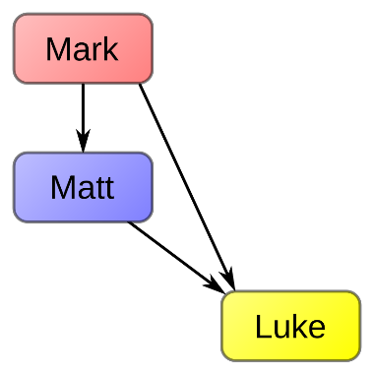

**The “Three Source” Hypothesis The “Griesbach” Hypothesis**

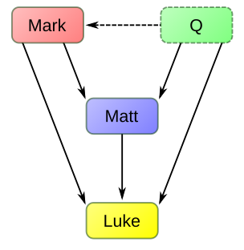 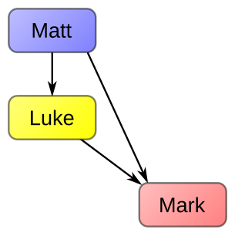

**Speculations around Gospel writers’ identity, date written, location:**

(There is no hard-and-fast evidence confirming anything you see below. Early church writers disagree with one another and many were writing decades (if not centuries) after when the Gospels were composed… the truth is we do not know the exact identity, dates, or locations of the Gospels!)

**The Gospel of Mark**

* A travelling companion of Paul named John Mark? (John Mark appears in Acts 12 + 13)
* The cousin of Barnabas? (Mark, the cousin of Barnabas, in Colossians 4:10 + Philemon 24)
* Recorded the testimony of Peter? (according to Eusebius, circa 320 CE)
* Written in Rome? (according to Clement of Alexandria, circa 200 CE)
* Written between 65-75 CE? (based off Mark 13’s accuracy on First Jewish Revolt in 70 CE)

**The Gospel of Matthew**

* One of the disciples of Jesus? (as stated by Papias, Origen, and Eusebius)
* A tax collector? (Comes only from Matthew’s gospel; Mark/Luke state Levi instead)
* Did Matthew use Mark as a source? (open question, but most scholars believe yes)
* Written in Antioch? (Gospel seems to have been very influential in other Antiochian texts)
* Written between 70-85 CE? (assuming Matthew used Mark; potentially earlier elements?)

**The Gospel of Luke**

* The “beloved physician” named in Colossians? (Colossians 4:14, Philemon 24)
* A first-hand witness to Paul’s ministry? (The “We” passages in Acts – Acts 16, 20, 21, 27)
* Written in excellent Greek – scholars assume that Luke was trained as writer
* Written to a Roman official named “Theophilus”… or anyone who is a “God-lover”?
* Written between 80-95 CE? (Did Luke use Matthew? Why similarities to Josephus?)

**The Gospel of John**

* Gospel based off the testimony of the “Beloved Disciple”… is this John, the disciple of Jesus? Is it the same John who Paul states as a “pillar of the early church”? (Galatians 2:9)
* Is there a connection to “John the Elder”? (Seen as different by Papias, Eusebius)
* The same author as 1, 2, and 3 John? (similar vocabulary and writing, according to scholars)
* The same author as Revelation? (unlikely since writing is starkly different)
* Written between 90-100 CE? (based off Jewish-Christian relations, potential use of other Gospels – though other elements of the Gospel seem to reflect pre-70 CE Jerusalem)

-----------------------------------------------------------------------------------------------------------------

**For further reading:**

* **Burton Throckmorton, *Gospel Parallels***, updated 1992 – side-by-side comparison of Matthew, Mark, and Luke’s texts with minimal commentary and excellent textual notes
* **Mark Goodacre, *The Synoptic Problem***, published 2001 – out-of-print but available online for free! Excellent summary of various approaches to understanding the Gospels’ relationship
* **Bart Ehrman, *The New Testament***, sixth edition in 2015 – broad overview of the entirety of the New Testament with excellent chapters highlighting each of the Gospels and their emphases
* **James Barker**, ***Writing and Rewriting the Gospels***, released in 2025 – very recent release examining the current state of scholarship around the Gospels